IP CABLING TRANSMISSION
ITEM NO.: IP03P POE Extender over Two Wire
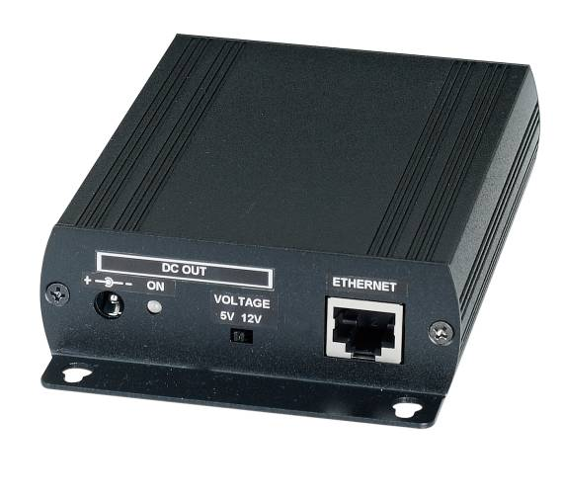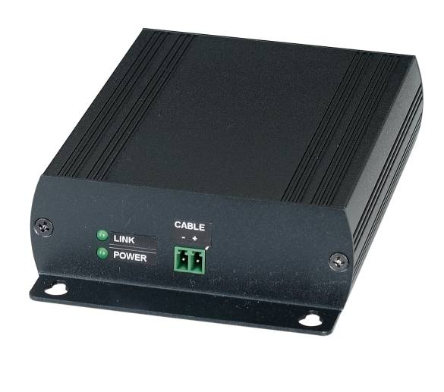
IP03P POE Extender is designed to send and extend Ethernet network with POE can be established using existing cables up to 500M. You can use a two-wire cable (UTP cable, coax cable, telephone line, antenna cable, or bell wire) that is no longer in use to connect a 10/100Mbps POE device, IP telephone, PC…etc without having to lay any new cables. Extended pass through POE to allow a single POE source, such as a POE network switch (IEEE 802.3af/at) to provide power to both TX/RX and the IP/POE camera use. It is perfect solution for extended distance data and power transmission for warehouses, parking lots, campuses, casinos and many more.

IP03P POE Extender over Two Wire
- Extend Ethernet or any TCP/IP devices up to 1Km.
- Ethernet and POE data over any two wire cable: UTP, Coax, telephone, bell, alarm, power cables.
- Data transfer distance up to 500M, data rate is up to 30Mbps based on distance.
- Support 10/100 Mbps transmission rate.
- Flexible power source either POE Switch or external DC power adapter option. (order separately)
- Provides pass-through POE up to IEEE802.3at 30W.
- Support high power POE to PTZ cameras at long distances.
- Connected devices are supplied with up to 7W via POE.
- IP03P Power Source Option Model:
DC48V 40W power adapter: SWP480830R
DC56V 70W power adapter: SWP551260
POE Injector/POE Switch: IP05I, IP05H
High Power POE Injector/ POE Switch: IP06I, IP06H

Installation View:
1. Connect IP03PT, IP03PR with any two wire cable at both ends before powering.
2.Power input source could use POE Injector/Switch either optional DC 48V, DC56 power adapter to IP03PR unit and camera use.

IP03PT with POE switch power input to IP03R and POE camera

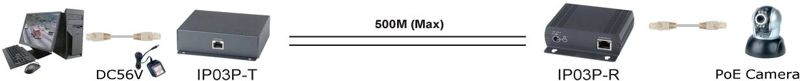

IP03PT with DC 48/56V Power adapter power input to IP03R and POE camera

IP03PT with POE switch power input to IP03R and Non-POE IP camera.

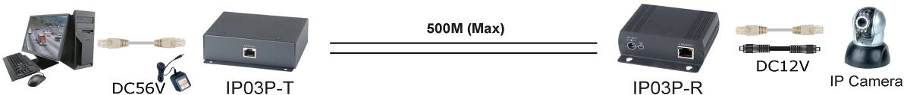
IP03PT with DC 48/56V Power adapter power input to IP03R and Non-POE IP camera

Different Two Wire Cables distance :
Please note the cable quality, length and diameter of two wires used all have an influence on the transfer of data and the POE output.
Coaxial cable
0.6 mm inner conductor
Data: 50 Mbps, Power: 13 W with 100 m
Data: 50 Mbps, Power: 11 W with 500 m
Data: 45 Mbps, Power: -
Telephone line/bell wire
0.8 mm
with 50 m Data: 50 Mbps, Power: 13 W with 100 m
Data: 50 Mbps, Power: 13 W with 200 m
Data: 50 Mbps, Power: 13 W
Installation cable
1.5 sqmm
with 50 m Data: 50 Mbps, Power: 13 W
with 100 m Data: 50 Mbps, Power: 13 W
with 200 m Data: 50 Mbps, Power: 13 W
Network cable
Cat-7
with 200 m Data: 50 Mbps, Power: 13 W
with 300 m Data: 50 Mbps, Power: 13 W
with 500 m Data: 45 Mbps, Power: 12 W
Cable Define：

Data/Power +
Data/Power –

LED Indication：

Green ： Power on/off

Link Yellow ： Slow flash → under connection
On → Connection, but without data transmission
Quick flash → Connection and Data transmission

Ethernet Green ： ON → 10/100 Mbps connection
Flash → Data Transmission.

Ethernet Yellow ： No function

Caution:

Power output will be varied based on the power source input.

IP03PR power input with two selections, but one time only could use one input
- Once choose power adapter power input, it cannot accept POE devices input.

IP03PT power output with two selections, but one time only could use one method.
- Once choose DC 12V 1A power output, it cannot use POE output power supply.

Panel View:

IP03T
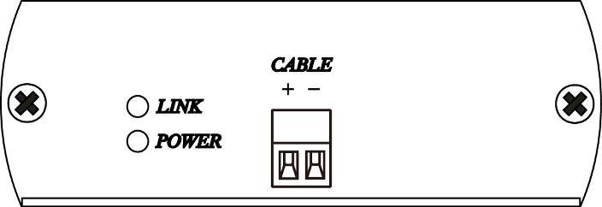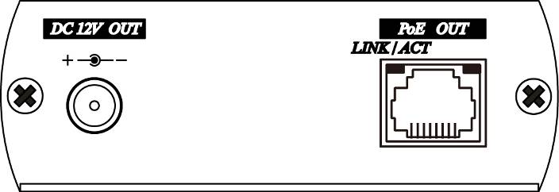

IP03R
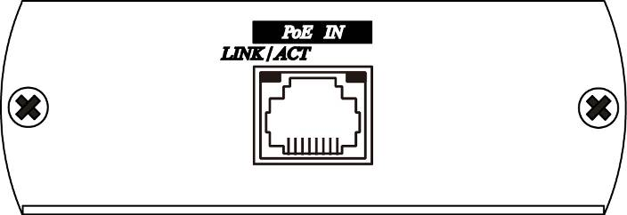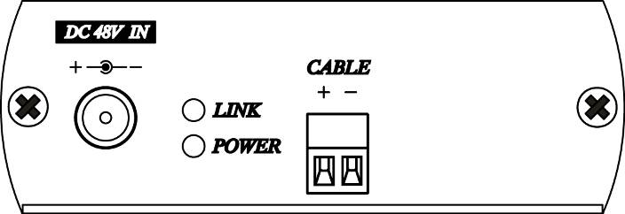

Specifications:

ITEM NO. | IP03PT | IP03PR
Data Input /Output | 10/100 Base-TX RJ-45, Auto-negotiation/ auto-MDI/MDI-X
Power, Data  Input /Output | Two port terminal block
Distance | Ethernet: 1000 Meters, POE: 500 Meters (Max) based on cables
Power Source | POE injector/Switch 802.3at/af POE or DC 48V/DC56V power adapter  (order separately)
LED Indication | Ethernet (Green) x 1, Power (Green) x 1,Link (Yellow x 1
Protection | ESD Protection: 30KV, 1KA @ 8/20us
Data Rate | Uplink： Mbps , Downlink：Mbps | Uplink：Mbps, Downlink:Mbps
DC Input /DC Output | Input：Adapter DC48V/DC56VC (0.83A) | Output：DC5V (1.3A),DC 12V (0.8A)
DC Input /POE Output | Input：Adapter DC48V/DC56VC (0.83A) | Output：POE 48V (11W)
POE Input /DC Output | Input：IEEE 802.3af POE 48V/56V (15W/30W) | Output：DC 5V (1.3A),DC 12V (0.8A)
POE Input /POE Output | Input：IEEE 802.3at POE 48V/56V (15W/30W) | Output：POE 48V (8.5W)
Switch | x | MODE POE / DC,VOLTAGE 5V / 12V
Temperature | Operation: 0 to 55℃, Storage: -20 to 85℃, Humidity: up to 95%
Dimension mm | 88x140x30mm | 88x130x30mm
Weight g | 280 g | 270 g

Rev. A

